**Software Engineering Mini Project**

**Project Title:**

**Covid Management System**

**Team members:**

|  |  |
| --- | --- |
| Name: Anoushka Chatterjee Roll NO: 211  Division: A | Name: Kabir Saigal Roll NO: 346  Division: B |
| Name: Kanav Bari Roll NO: 306  Division: B | Name: Raj Rakade Roll NO: 343  Division: B |

1. **Problem definition**

* Registration and tracking of Covid patients
* Single encrypted database to store name, age, height, weight and other personal details of every patient.
* Generate tokens for RT-PCR testing at the nearest Centre.
* Sorting patients by area
* Each user will have a unique UID
* Prepare list of vaccinated patients who have taken the first dose as well as second dose.
* Allot timing to patients, coming for covid testing and vaccinations.
* Issue digital certificate for covid negative patients
* Track the recovery rate of patients.

1. **Study of Existing system (Manual or computerized)**

There is manual system which provides solution to manage present covid situation in rural and remote areas.

* Covid patient details are entered through pen and paper.
* Forms are submitted by hospitals to confirm their registrations.
* Registers are maintained to record information of all registered positive patients.
* Patients’ response is recorded in hard copy of registers.
* Number of patients are evaluated manually by referring to the corresponding registers.
* The status of the patient is shared through post.
* Reports are prepared manually with the help of current data maintained in registers.
* Once the currently used register is over, it is immediately sent to the government for the analysis of the current situation.

1. **Drawbacks of Existing system**

As Covid system in rural areas is managed manually, it has following drawbacks-

* Covid patient details may not reach to the concerned person timely resulting in delay of treatment.
* It is inefficient to use registers to store information.
* Restriction on number of tokens issued as they are assigned manually.
* It is extremely laborious to maintain record of covid patients manually and it may produce human errors.
* As the records are maintained in registers, it is easy to manipulate or lose the information.
* It is very tedious job to create reports manually.
* As the results are delivered through post, it will take a lot of time to inform the patient of his status.
* Since reports are generated manually, not many reports can be generated in a day, yet again causing a delay in the further treatment.

1. **Scope of the Proposed System**

The scope of covid system includes:

* Advertise details of covid testing.
* Register covid positive patients onto the database for their treatment.
* Generate tokens for all people coming for testing or vaccination.
* An interface for hospitals and testing centers to add information.
* An interface for family members to track progress of their dear ones back at the hospital.
* Generate reports according to patient status.
* Issue digital certificates for negative patients.
* Issue digital certificates for people who have taken first dose or second dose of vaccine.
* A report page to view details like active and recovered cases, area wise.

**Feasibility Study**

* **Technical Feasibility**

Technically it is feasible to get the required hardware and software for the development and use of system as project requirements are-

1. Higher level programming language

2. Postgres SQL database

3. A system with internet connection to access website.

* **Economic feasibility**

Economically it is feasible develop and use the system as -

1. No extra hardware and software is needed.

2. No extra training is required for staff to use this system as system is user friendly.

3. The cost of proposed system is beneficial against cost and efforts involved in maintaining the various registers, books, files and generation of various reports.

* **Operational Feasibility**

Operationally it is feasible as-

1. System is user friendly; it provides Graphical User Interface that will be easily understood by user.

2. To use system, end user does not need knowledge of programming language and database used.

3.A person who is able to use computer or a phone can use system.

**Entity Relationship Modelling**

**Patient**

* Name
* Age
* Height
* Weight
* Address
* Phone number
* UID
* Patient status

**Hospital**

* Name
* Location
* Contact number
* No. of covid patients
* Covid beds available
* Hospital ID

**Vaccine**

* Name
* Doses required
* Efficacy rate
* Vaccine ID
* Price

**Vaccination center**

* Name
* Location
* Capacity
* Center ID

Vaccination Centres

Go to

1

1

M

1

1

M

1

1

Administer

Administer

Vaccine

Hospital

Go To

Patients

1

1

Can Take

**ENTITY RELATIONSHIP DIAGRAM**

**Designing the Normalized Database**

|  |  |  |
| --- | --- | --- |
| **Table 1** | **Relationship** | **Table2** |
| Hospital | One-to-many | Patient |
| VaccinationCentre | One-to-many | Patient |
| VaccinationCentre | Many-to-many | Vaccine |
| Hospital | Many-to-many | Vaccine |

**Fields of individual Tables**

1. **Table Name: Patients**

|  |  |  |
| --- | --- | --- |
| **Field Name** | **Field Type** | **Description** |
| UID | Int | Primary key to store Unique Identification number of patients. |
| P_name | Varchar | It is used to store the names of the patients. |
| Age | int | Used to store age of the concerned patient. |
| Height | int | Stores the height of the patient. |
| Weight | int | Stores the weight of the patient. |
| Phone_number | varchar | A multivalued attribute to store the contact number of patients. |
| Address | text | This variable is used to store the address of the patient. |
| P_status | varchar | This variable will store the current status of the patient-whether he/she is covid positive or negative. |
| HID | int | Primary key of the hospital table to store hospital ID as it shares a one-to-many relationship with patient table. |
| VID | int | Primary key of the vaccination centre table to store vaccination ID as it shares a one-to-many relationship with patient table. |

1. **Table Name: Hospital**

|  |  |  |
| --- | --- | --- |
| **Field Name** | **Field Type** | **Description** |
| HID | int | Primary key to store Hospital ID |
| H_name | varchar | Variable to store the name of the hospital |
| H_loc | varchar | Variable to store the location of the hospital. |
| P_no | varchar | It stores the contact number of the hospital. |
| No_cpatients | int | It stores the number of covid patients currently present in a hospital. |
| Covid_beds | int | It stores the number of available covid beds in a hospital. |

1. **Table Name: Vaccine**

|  |  |  |
| --- | --- | --- |
| **Field Name** | **Field Type** | **Description** |
| VID | int | Primary key to store vaccine ID. |
| Name | varchar | Variable to store the name of the vaccine. |
| Doses | int | Variable to store the number of doses required for the chosen vaccine. |
| Efficacy_rate | float | Variable to store the efficacy rate of the vaccine being administered. |
| Price | money | It stores the price of the vaccine. |

1. **Table Name: VaccinationCentre**

|  |  |  |
| --- | --- | --- |
| **Field Name** | **Field Type** | **Description** |
| C-Id | int | Primary key to store the centre ID. |
| Name | varchar | Variable to store the name of the vaccination centre. |
| Loc | varchar | Variable to store the location of the vaccination centre. |
| Capacity | int | This variable stores the capacity of the vaccination centre, that is, the maximum number of people it can accommodate at a given time. |

1. **Table Name: VaccinationCentre_Vaccine**

|  |  |  |
| --- | --- | --- |
| **Field Name** | **Field Type** | **Description** |
| VID | int | Foreign key to store the primary key of vaccine table. |
| C-ID | int | Foreign key to store the primary key of vaccination centre table. |
| Stock | int | Descriptive attribute to store the currently available stock of the vaccine in the corresponding vaccination centre. |

1. **Table Name: Hospital_Vaccine**

|  |  |  |
| --- | --- | --- |
| **Field Name** | **Field Type** | **Description** |
| HID | int | Foreign key to store the primary key of Hospital table. |
| VID | int | Foreign key to store the primary key of vaccine table. |
| Stock | int | Descriptive attribute to store the currently available stock of the vaccine in the corresponding Hospital. |

*IMPLEMENTATION:*

Database Tables:

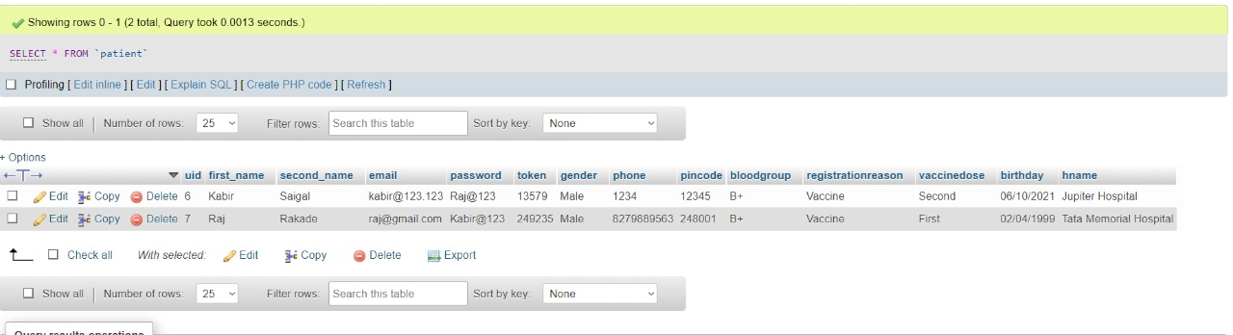

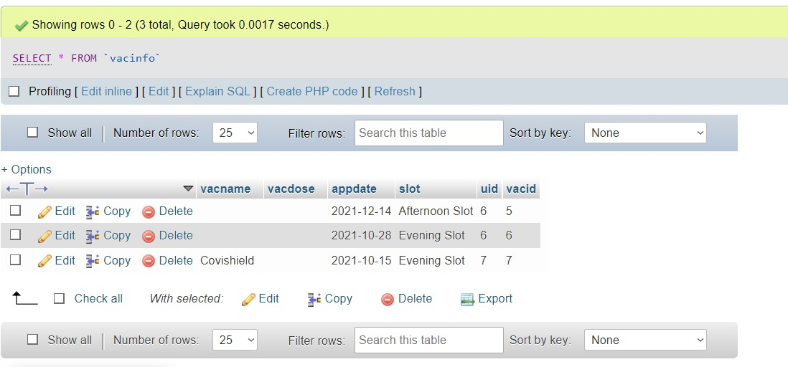

HOME PAGE:

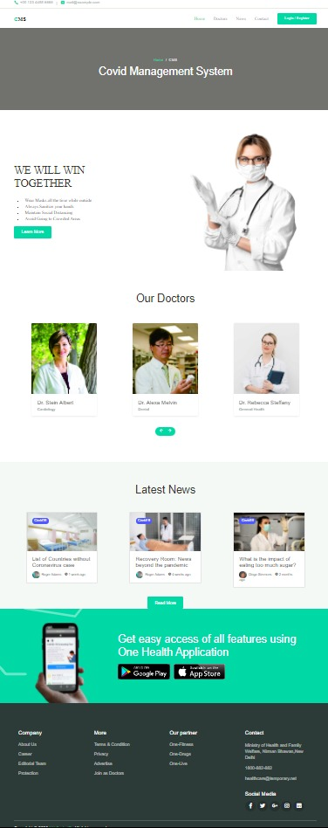

REGISTRATION PAGE:

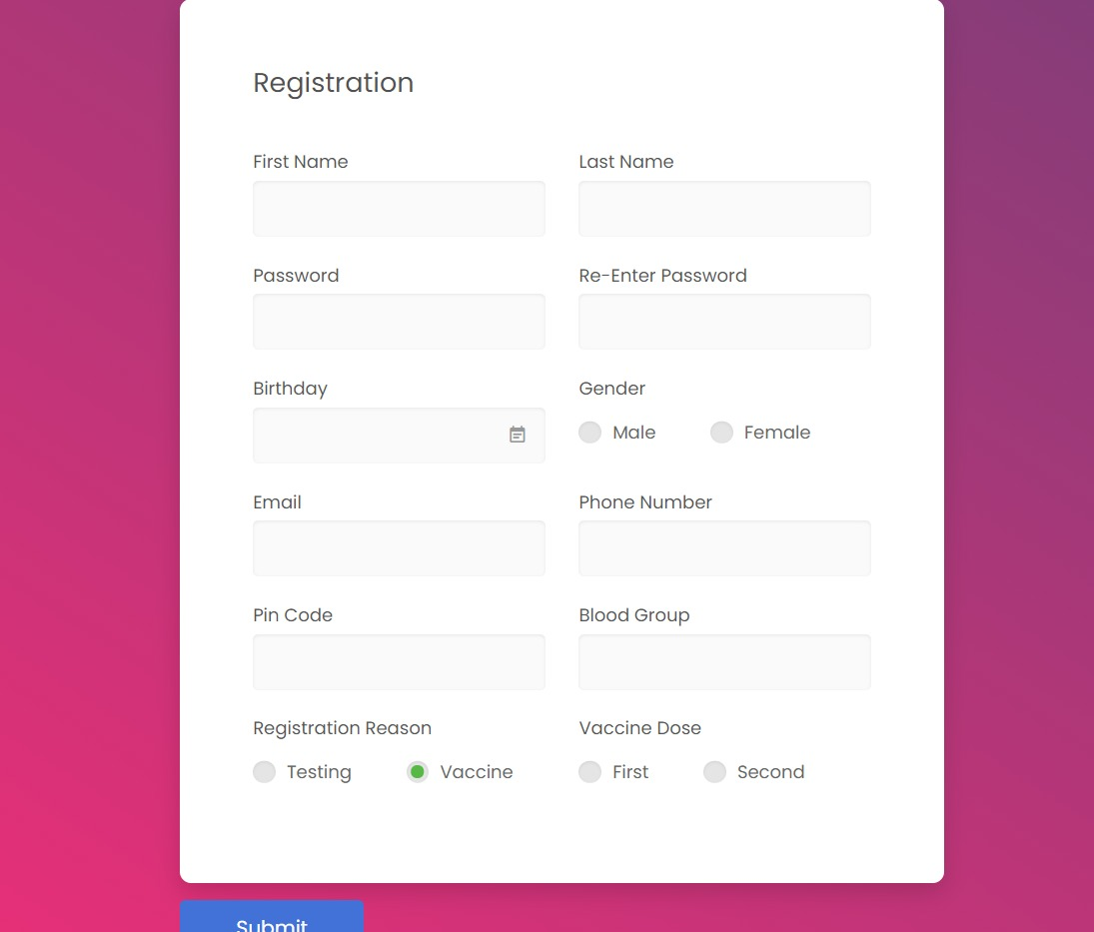

LOGIN PAGE:

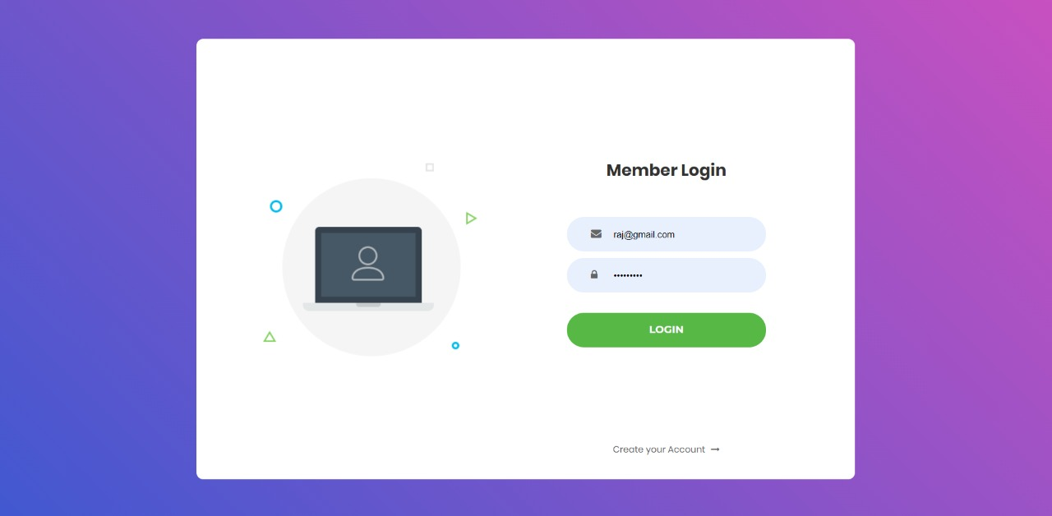

Vaccine slot booking:

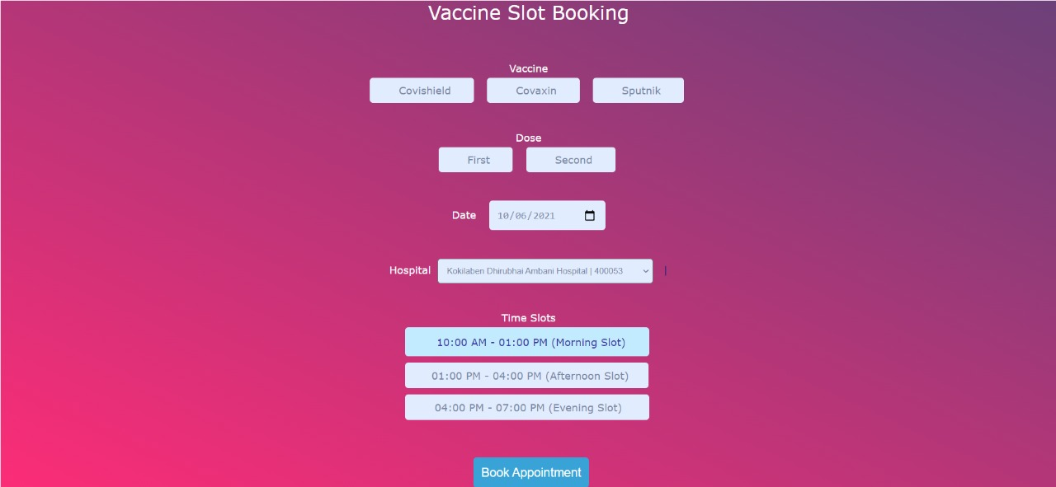

Successfully Registered:



PROFILE:

